**For the following exercises, you have to use a Windows 10 virtual machine**

## Exercise 1

* First, let us create a new 10 GB hard disk for the virtual machine
* Now, attach your DRBL ISO in the optical drive of your virtual machine.
* Then, we boot the virtual machine from the CD-ROM drive.
* Select English as laguage and Don`t touch heymap
* We run **Gparted** in DRBL desktop
* Check that you have two hard drives, especially the last one of 10 GB we have recently created.



* Select /dev/sdb (it is the second hard drive according to Linux naming conventions)
* Let us create our partition table through the menu: Device → Create Partition Table… → msdos (this means MBR)
* Right-button click on the unallocated space

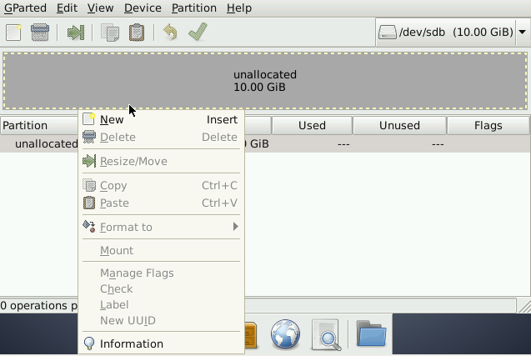

* Choose the “Partition -> New” menu option and a new partition window is displayed
* We are going to create a Primary Partition of 2GB, whose file system is NTFS and its name PNTFS

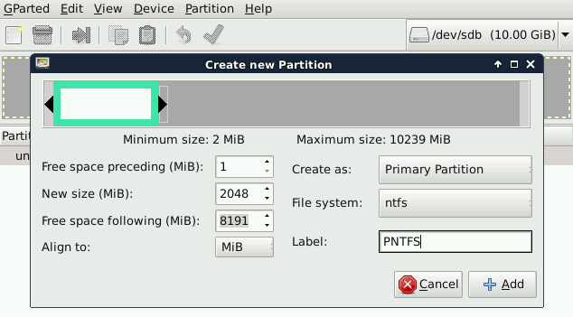

* Click on **+Add**
* We create another primary partition of 2GB, EXT4 file system and PEXT4 label.

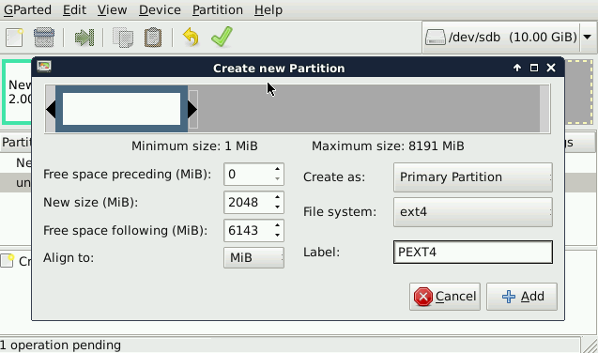

* Now, we do the same process to create an extended partition using all the available space. We set PEXTENDED as label

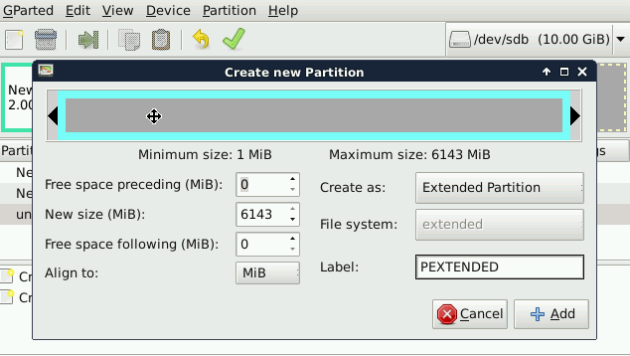

* We just realize that we wanted to create a smaller partition, so we can “Delete” o “Resize” it by clicking on the right-button over the partition.

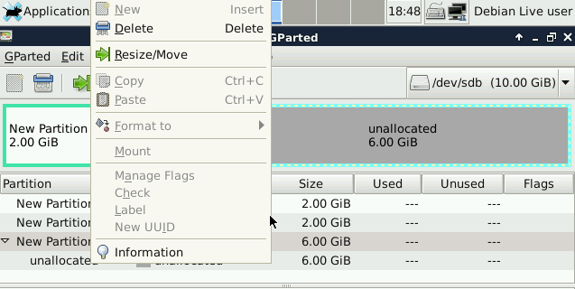

* If you “Delete” the partition, it will be necessary to create a new extended partition in the same way as before. If you “Resize”, just type the new size in MB.
* Afterwards, right-click over the extended partition and create a logical unit of 2 GB, which has 2GB, FAT32 file system and PFAT32 label (take into account that we can only create logical partitions in extended partitions)

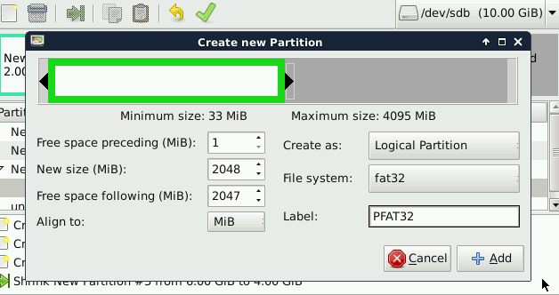

* As a result, we will have 2 GB unallocated space both in the extended partition and in the rest of the disk.
* Do not forget to click on **Apply** to save all the operations.

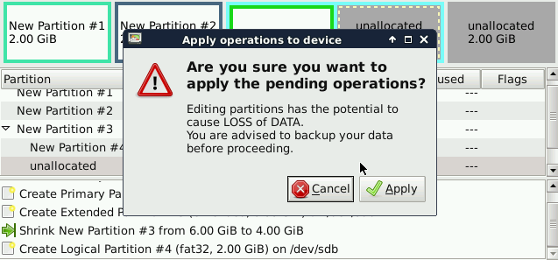

* Once you have applied all the operations, check if the partitions are as in the picture below.

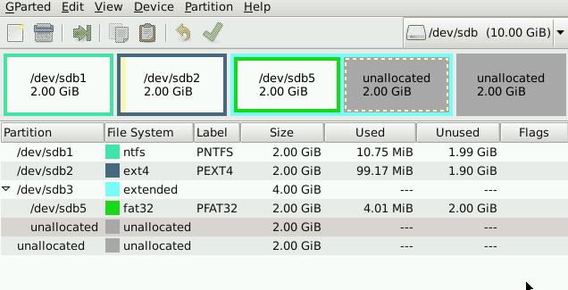

* Close GParted
* Click on **Exit** button
* Select **Shutdown**

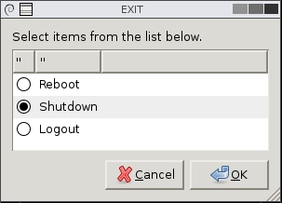

Let us go to the Windows Disk Management to see how the partitions have been created. Your disk should look like similar as follows:

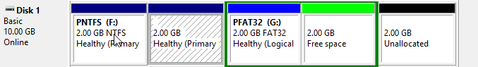

1. Why is the file system not showed in the second partition?

Windows does not recognize EXT4 file system

1. If you had to create a new partition to store 2 GB data, where would you put the partition in? Which file system should you use? Justify your answer.

We can use either the extended partition or the free space outside to create a primary partition. Anyway, because of the fact that we are using Windows, the file system would have to be NTFS, FAT16 or FAT32.

## Exercise 2

Create a new disk of 5GB in the same Windows 10 virtual machine. Now, configure the partitions with GParted to get the following result:

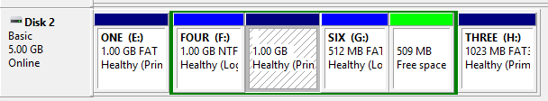

Answer the following questions

1. How does GParted name the new hard disk?

/dev/sdc

1. List all the partitions you have created, indicating type and file system.

* Primary: Label One, 1024 MB, FAT16
* Extended of 3.072 MB
  + Logical: Label Four, 1024MB, NTFS
  + Logical: Label Five, 1024GB, any non-Windows file system
  + Logical: Label Six, 512MB, FAT32
* Primary: Label Three, 1024GB, FAT32